LOKI
an open-source log aggregation system created by Grafana. Often described as "Prometheus, but for logs," it is designed to be highly scalable, cost-effective, and easy to operate.
How Loki Works
Unlike traditional logging systems like Elasticsearch, Loki does not index the full text of your logs. Instead:
- Label-Based Indexing: It only indexes the metadata (labels) associated with log streams, such as app=webserver or env=prod.
- Compressed Storage: The actual log data is compressed and stored in "chunks" within inexpensive object
- Query Language: It uses LogQL, which is heavily inspired by Prometheus's PromQL, allowing you to filter, aggregate, and even generate metrics directly from your logs.
The Core Logging Stack
A complete setup typically involves three main parts:
- Agent: A log collector like Grafana (which recently replaced Promtail) that scrapes logs and pushes them to Loki.
- Loki: The central server responsible for ingesting, storing, and processing queries.
- Grafana: The visualization layer where you search, filter, and build dashboards to view your logs alongside metrics.
Key Benefits
- Cost-Efficient: By avoiding full-text indexing, it requires significantly less storage and memory than other solutions.
- Seamless Integration: It is built to work natively with the Grafana observability stack, allowing you to correlate logs with metrics and traces in a single view.
- Scalable: It can scale from a single process to massive, distributed clusters capable of handling petabytes of data.

  - Install Loki

Download Loki
wget https://github.com/grafana/loki/releases/latest/download/loki-linux-amd64.zip
unzip loki-linux-amd64.zip
chmod +x loki-linux-amd64

sudo mv loki-linux-amd64 /usr/local/bin/loki

Create config file
nano loki-config.yaml

Paste this basic config:
auth_enabled: false
server:
http_listen_port: 3100
common:
path_prefix: /tmp/loki
storage:
filesystem:
chunks_directory: /tmp/loki/chunks
rules_directory: /tmp/loki/rules
schema_config:
configs:
- from: 2020-10-24
store: boltdb-shipper
object_store: filesystem
schema: v11
index:
prefix: index_
period: 24h
limits_config:
allow_structured_metadata: false
chunk_store_config:
max_look_back_period: 0s
table_manager:
retention_deletes_enabled: false
retention_period: 0s

Run Loki
loki -config.file=loki-config.yaml

Loki now runs on:
http://localhost:3100

2. Install Promtail (Log Collector)

Promtail sends logs to Loki.

Download Promtail
wget https://github.com/grafana/loki/releases/latest/download/promtail-linux-amd64.zip
unzip promtail-linux-amd64.zip
chmod +x promtail-linux-amd64
sudo mv promtail-linux-amd64 /usr/local/bin/promtail

Create Promtail config
nano promtail-config.yaml
Paste:
server:
http_listen_port: 9080

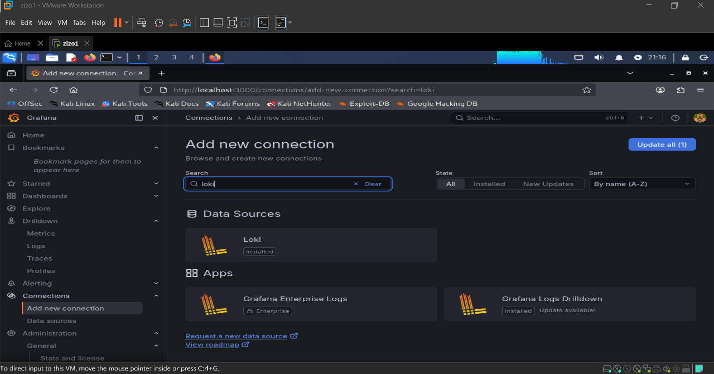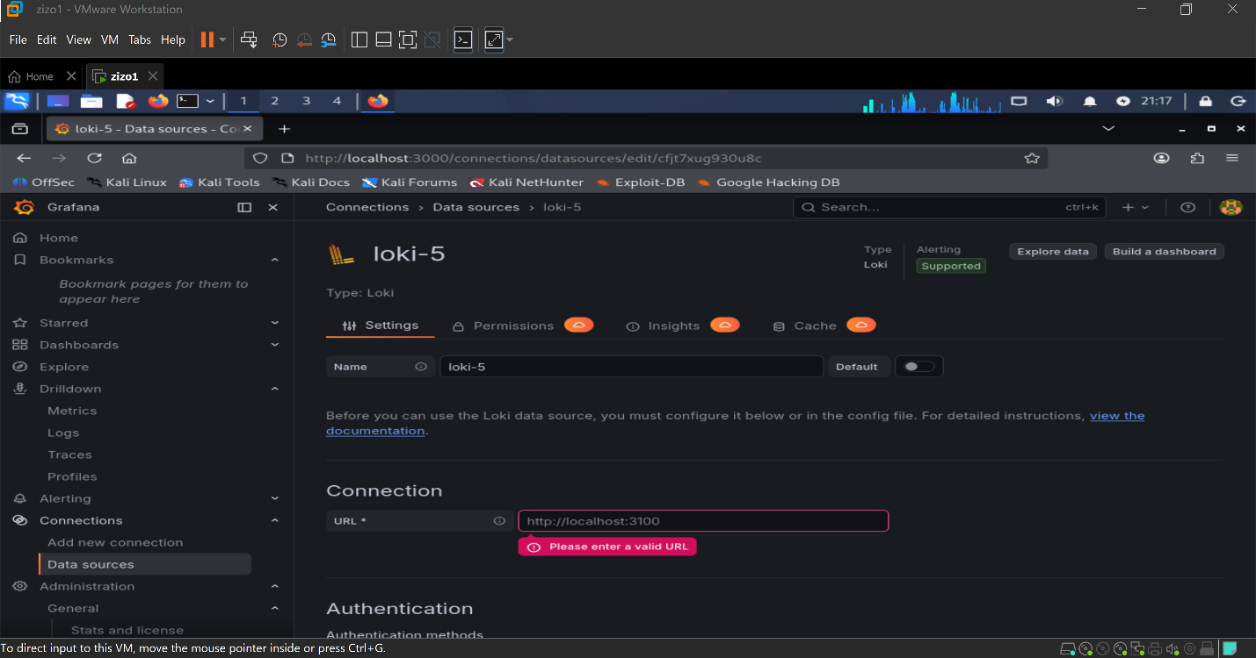

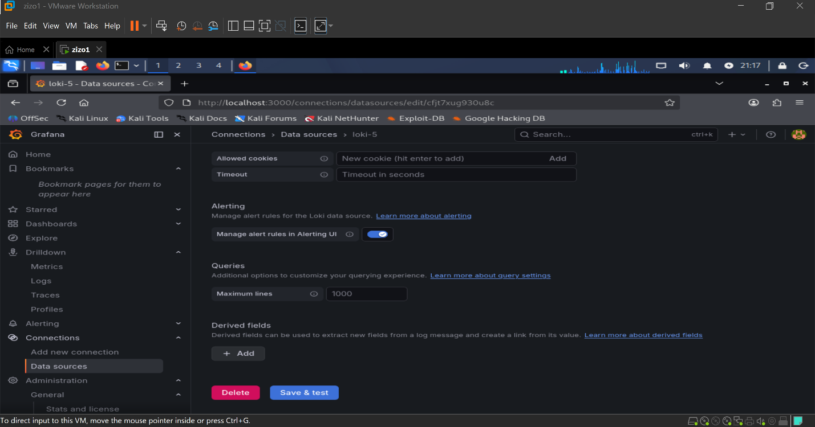
positions:
filename: /tmp/positions.yaml
clients:
- url: http://localhost:3100/loki/api/v1/push
scrape_configs:
- job_name: system_logs
static_configs:
- targets:
- localhost
labels:
job: varlogs
__path__: /var/log/*.log

Run Promtail
promtail -config.file=promtail-config.yaml
Now logs from /var/log are being sent to Loki.

3. Connect Loki to Grafana
Start Grafana
sudo systemctl start grafana-server
Explore loki
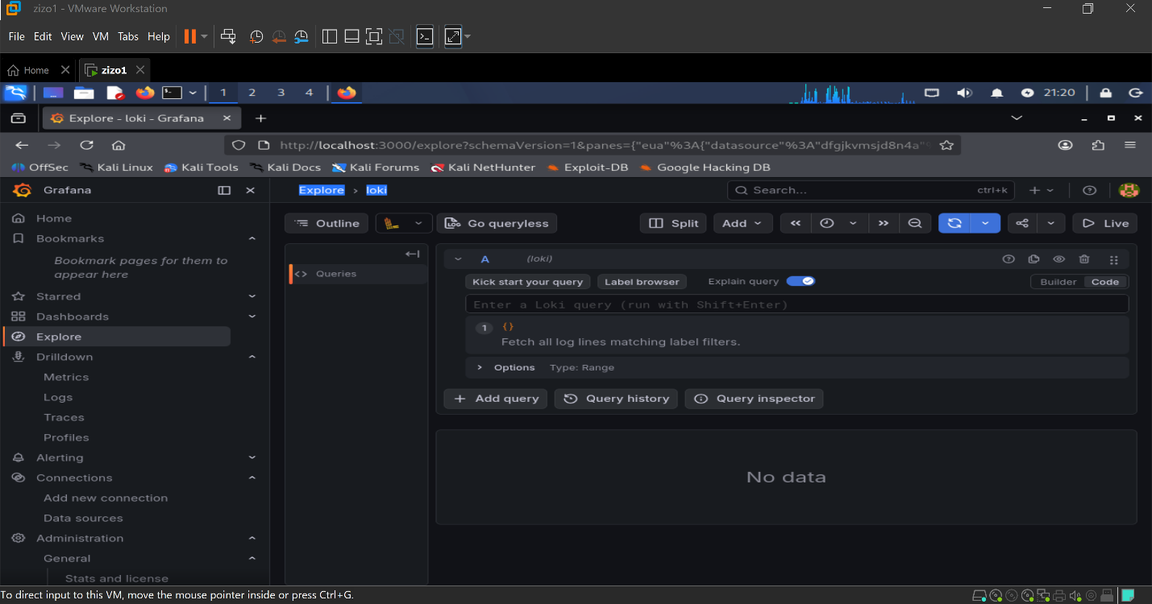
Add Quary box {job="zeek"}
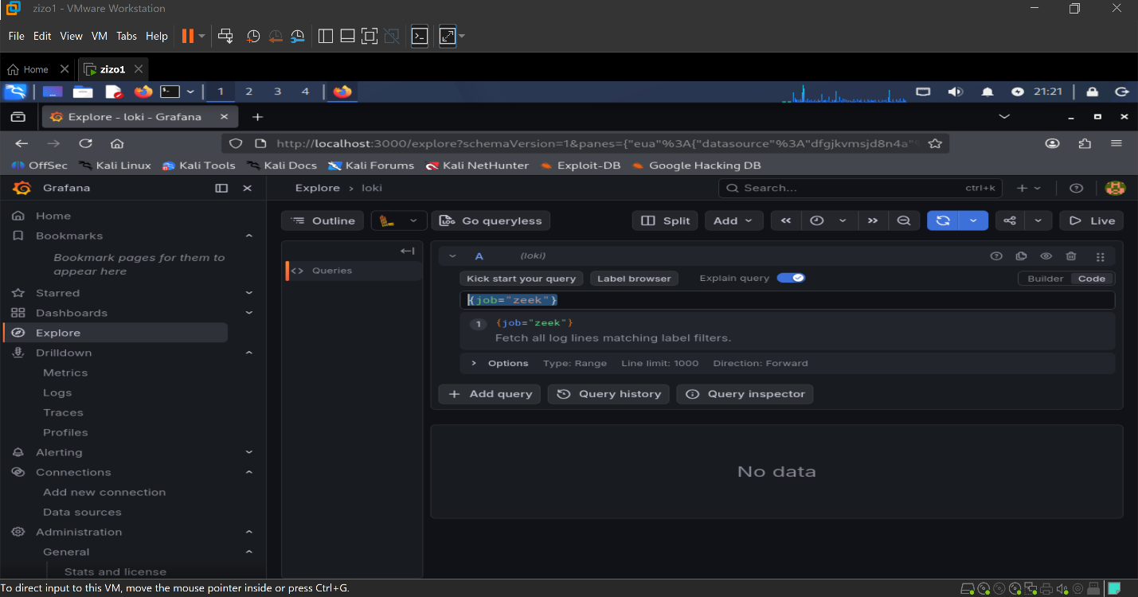
Now LOKI take information from zeek
